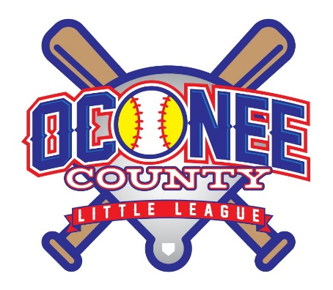

Oconee County
Little League
COVID-19 ProTOCOLS

Safety Officer
Ken Wells
kwells023@gmail.com
706-202-9442

Wesley Scott
Oconee County Little League President
ocllpresident@oconeelittleleague.com
706-461-1228

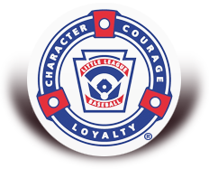

The safety and well-being of all our families, friends, and participants is always paramount, and today, is more important than ever. The following protocols provide guidelines for minimizing risk while still allowing our players to participate and compete in baseball and softball. We cannot guarantee adherence by all participants at all times. Families should make their own choices on participation and in the best interest of their family and players.

Oconee County Parks and Recreation Department (OCPRD) protocols
As a user group of OCPRD, OCLL will adhere to OCPRD Covid protocols. These can be found in the OCPRD document “COVID-19 PROGRAM PROTOCOLS AND BEST PRACTICES”.

OCLL Protocols

No Handshakes / Personal Contact celebrations
- Players and coaches should take measures to prevent all but the essential contact necessary to play the game.
- Refrain from handshakes, high fives, fist/elbow bumps, group celebrations, etc.
- As an alternative to post game handshake, line up outside the dugout and tip caps to the opposing team.

Player Equipment
- Players should have their own batter’s helmet, glove, bat, and catcher’s equipment.
- Initially, teams will be provided with one set of catcher’s equipment as many catchers have their own catchers gear. A coach may request additional sets of catchers gear and OCLL will provide them
- Players equipment should only be used by that player – no sharing of equipment

Drinks and Snacks
- Players, coaches and umpires should bring their own drinks to all team activities
- Drinks should be labeled with the person’s name
- There should be no use of shared or team beverages
- No post game “team” snacks

Scheduling
- Practice and game times will be scheduled to accommodate adequate spacing between events to minimize contact between arriving and leaving groups
- Players/coaches/spectators are instructed not to show up to fields before their designated time – if you arrive early, you are encouraged to stay in your vehicle until it is time for your event
- Players/coaches/spectators should vacate the field/facility as soon as is reasonably possible after the conclusion of their practice/game in order to minimize unnecessary contact with individuals from the next practice/game

Personal Protective Equipment
- All managers/coaches must wear face coverings
- Players are encouraged to wear face coverings while in the field of play
- Since social distancing is difficult in dugouts, players are required to wear face coverings while in the dugout.
- OCLL will provide each player with a face covering. Players may also use their own face covering.

Rosters
- Target team size will be 10 players

Spectators
- Stay six feet away from individuals outside their household
- Encouraged to wear face coverings
- Bring their own seating/portable chairs when possible

Final note – one of the best protections for our players and families is for parents to keep players and family members home if showing any symptoms related to COVID-19. If anyone has a fever, cough or has been in close contact with an individual testing positive for COVID, please keep them at home.

